Quick Guide for Running Weekly Tournament Results.

Open FantasyGolf.mdb for the downloaded GitHub Repository (I will explain how to download respository and also posting changes back to GitHub when complete)

1. Run the Macro Job “PrepareForTournamentLoad”
   1. This will clean out any staging tables from previous weeks so you will be ready to load the scores for the current week’s tournament.

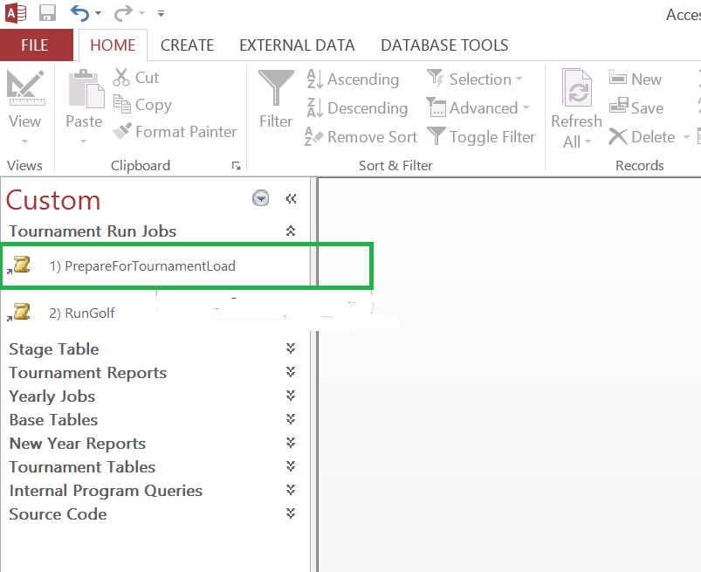

1. Download the respective weekly tournament scores from PGATour.com or similar site and format to fit into the Stage Table LeaderLoad. I will explain how to copy and paste this to Excel and MS Access to avoid having to type the values.

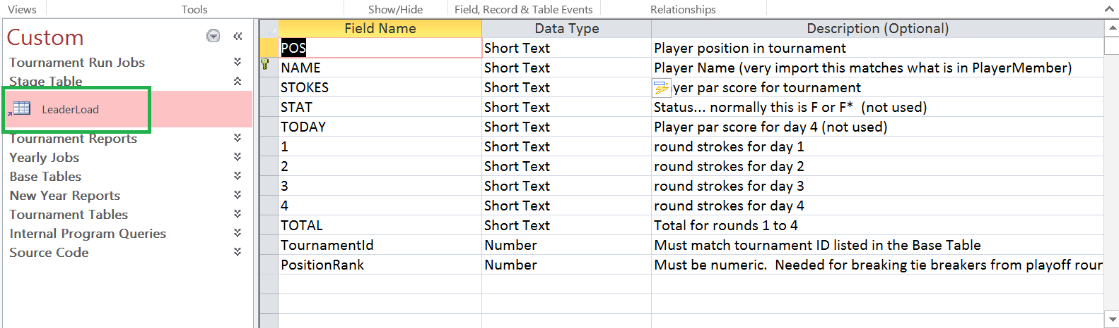

Sample values

| **LeaderLoad** | | | | | | | | | | | |
| --- | --- | --- | --- | --- | --- | --- | --- | --- | --- | --- | --- |
| **POS** | **NAME** | **STOKES** | **STAT** | **TODAY** | **1** | **2** | **3** | **4** | **TOTAL** | **TournamentId** | **PositionRank** |
| 1 | Cameron Smith | -11 | F | -2 | 70 | 65 | 66 | 68 | 269 | 1 | 1 |
| 2 | Brendan Steele | -11 | F | 1 | 68 | 66 | 64 | 71 | 269 | 1 | 2 |
| 3 | Webb Simpson | -10 | F | -3 | 71 | 66 | 66 | 67 | 270 | 1 | 3 |
| T4 | Kevin Kisner | -9 | F | -1 | 69 | 69 | 64 | 69 | 271 | 1 | 4 |
| T4 | Graeme McDowell | -9 | F | -6 | 71 | 69 | 67 | 64 | 271 | 1 | 4 |
| T4 | Ryan Palmer | -9 | F | -2 | 67 | 68 | 68 | 68 | 271 | 1 | 4 |

…

…

1. Run the job “RunGolf” and select Yes if the scores have been entered correctly into LeaderLoad Table.

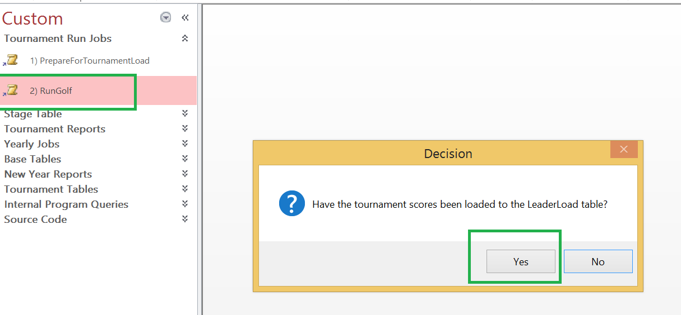

When the job completes you should see message the current weekly tournament was processed.

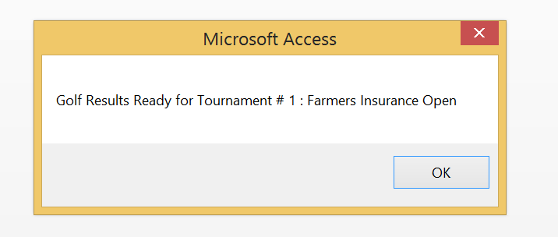

1. Double Check Results by reviewing the report “7) IndividualTournamentReport” to ensure there are not any PlayerName issues.. where name might be different. Note: This is real example. Brendan Todd vs Brendon Todd. (Fix PlayerMember Base Table and Rerun steps 1 to 3).
   1. Sorting report by PlayerName and reviewing if any “Not On Roster” show up with similar name helps to find issues.

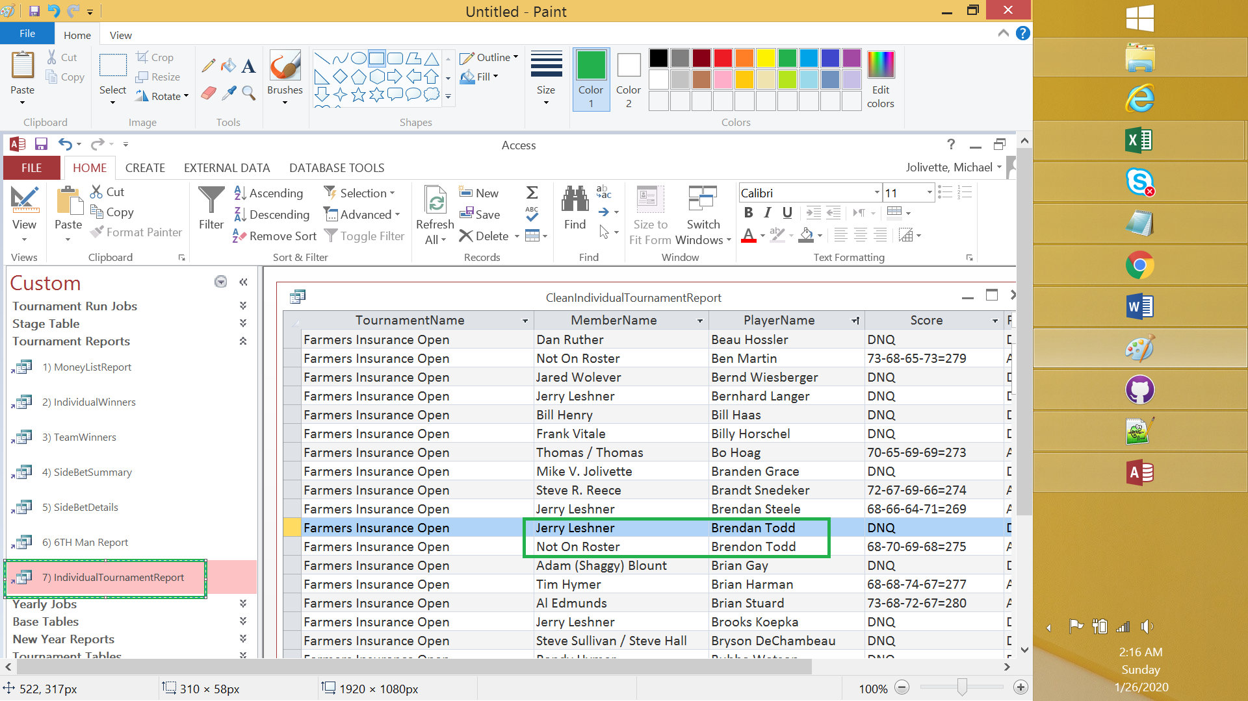

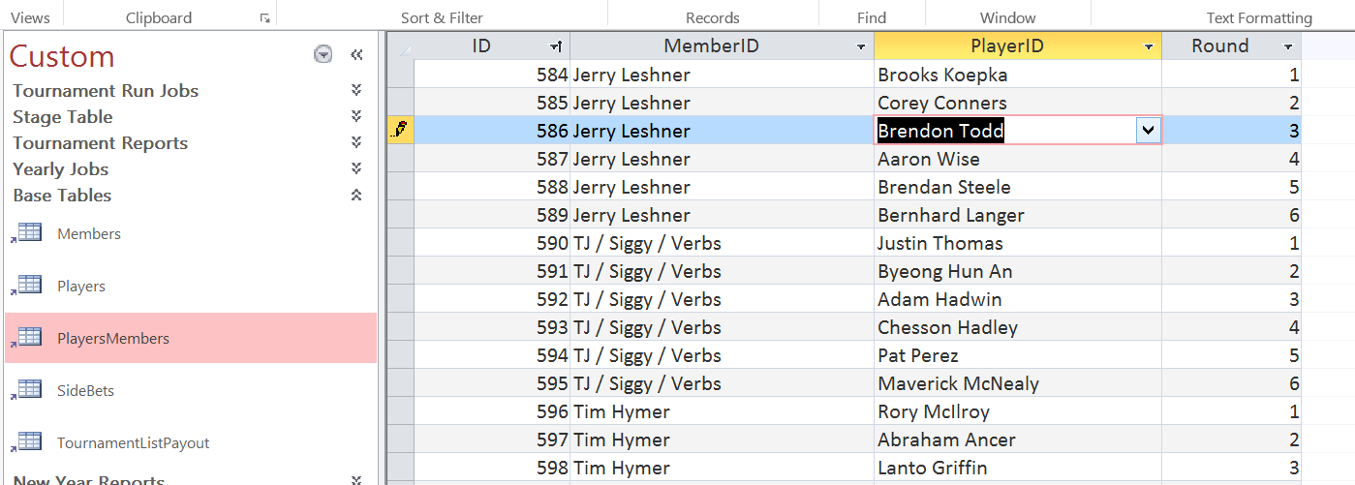

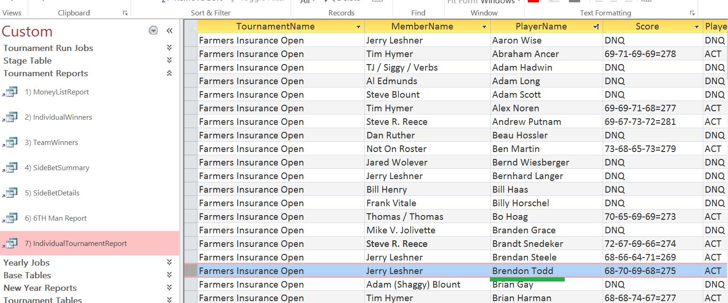

1. Open Index.Html for your local GitHub repository with MS Excel.

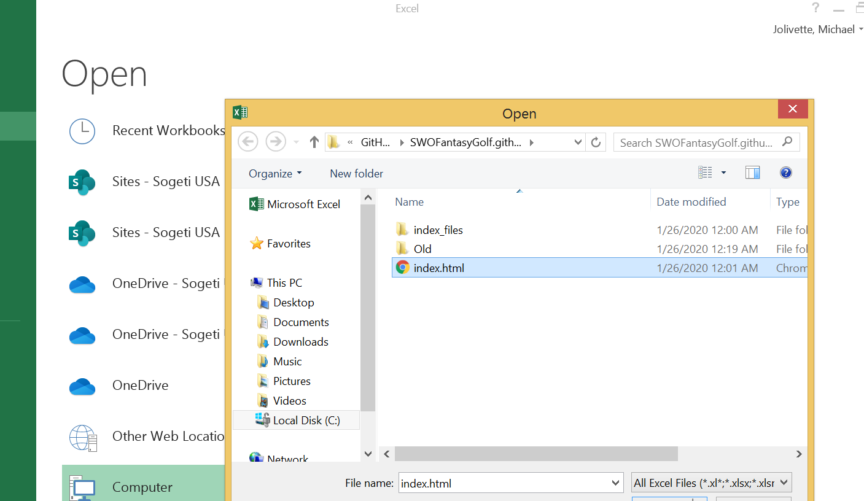

1. Update using Excel each of the respective tabs based on the corresponding MS Access Report
2. MoneyListReport is used to update the Money List on the Home Tab

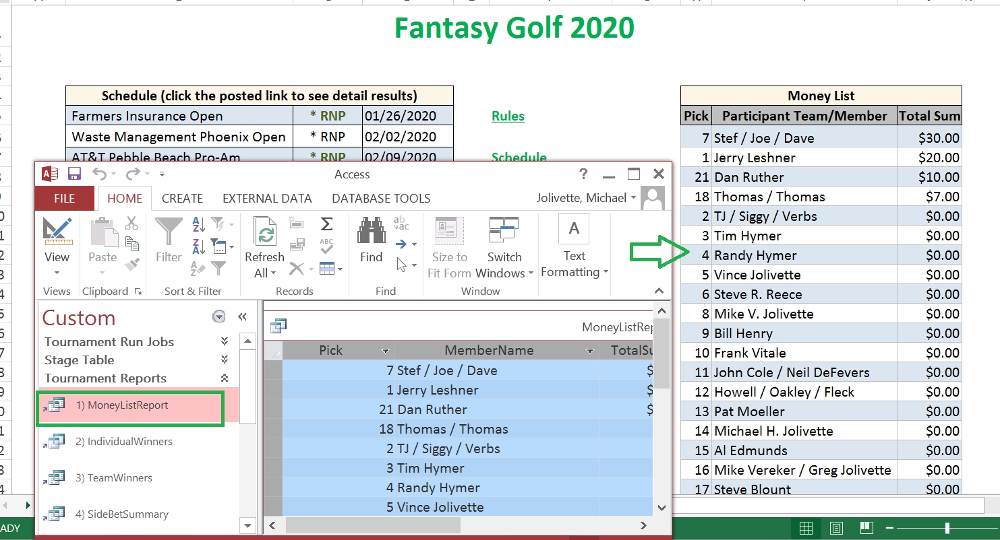

2) IndividualWinners is used to update the values in the Individual Winners Tab

3) TeamWinners is used to update the values in the Team Winners Tab

4) SideBetSummary …Same

5) SideBetDetails .. Same

6) 6TH Man Report .. Same

7) IndividualTournamentReport – This is the special Posted Report for the tournament.

A) . Create a new sheet by doing a copy of the “Put Name Here” Sheet

B). Update Name and load results from Individual Tournament Report into the new copy

C). On Home tab. Type Posted in the *RNP column for the respective tournament and create hyperlink to place in document that contains the individual tournament results.

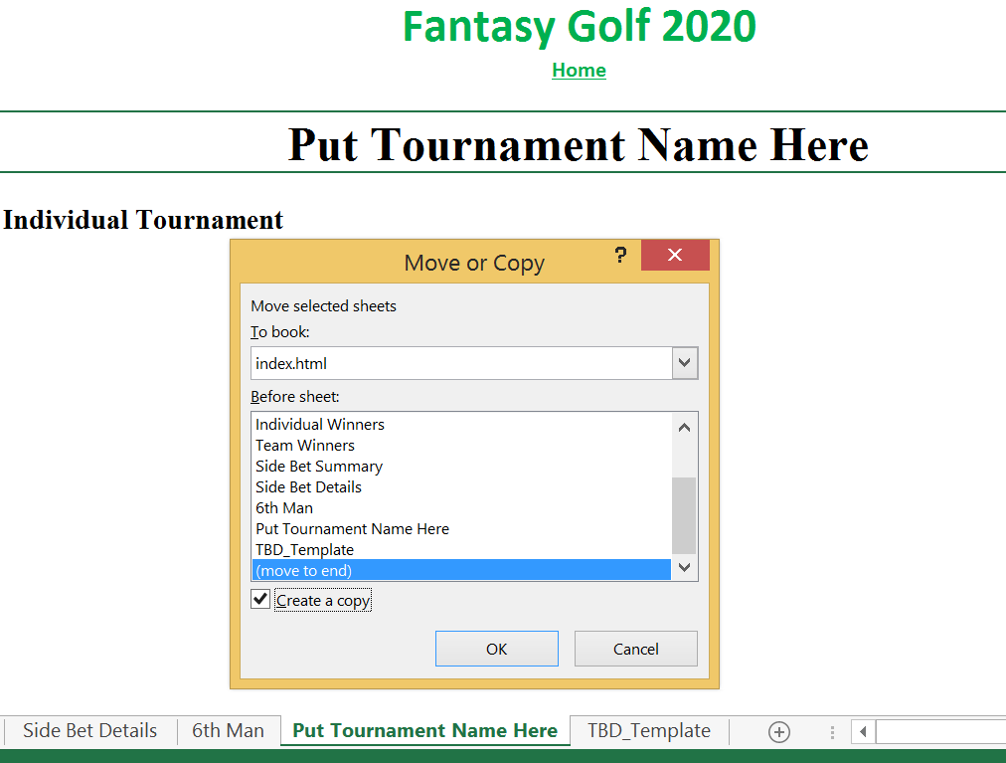

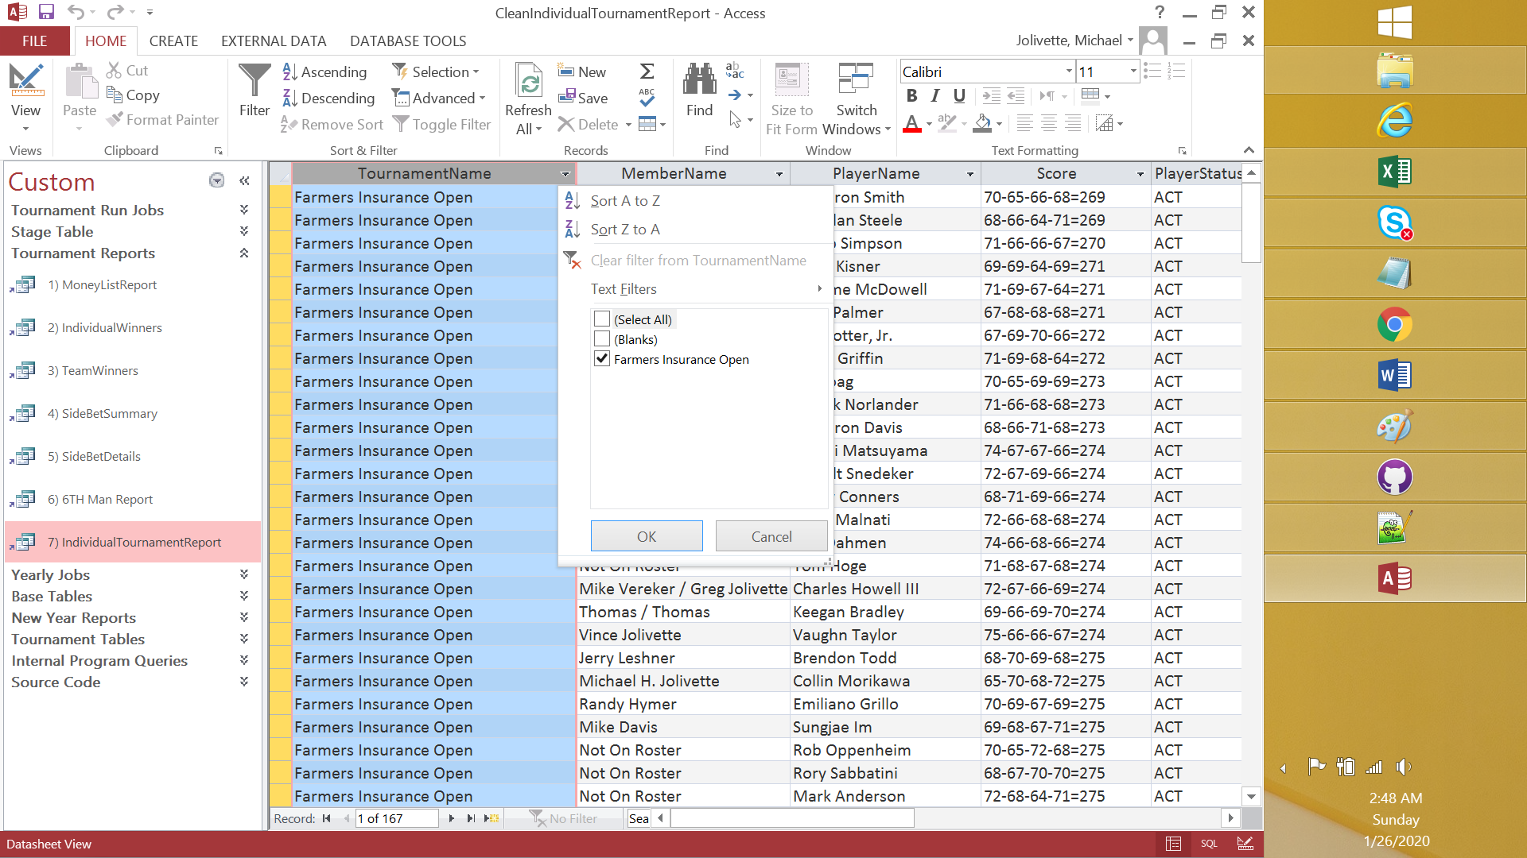

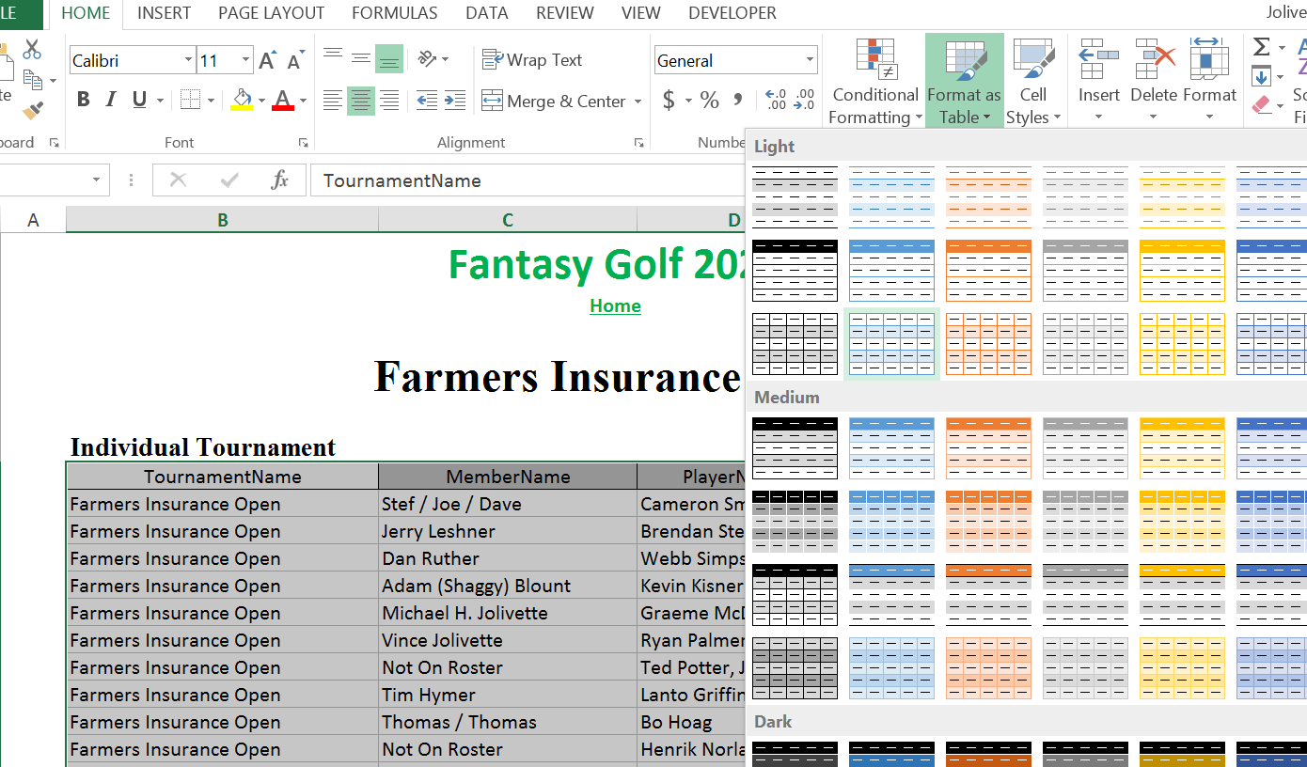

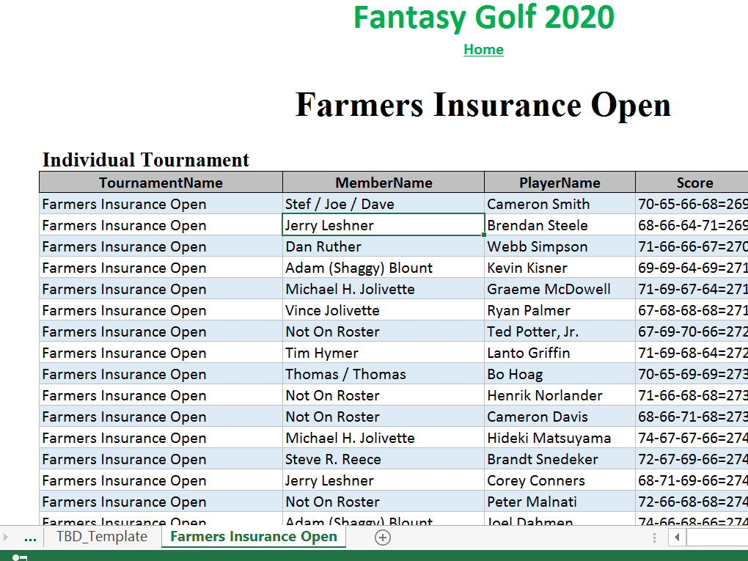

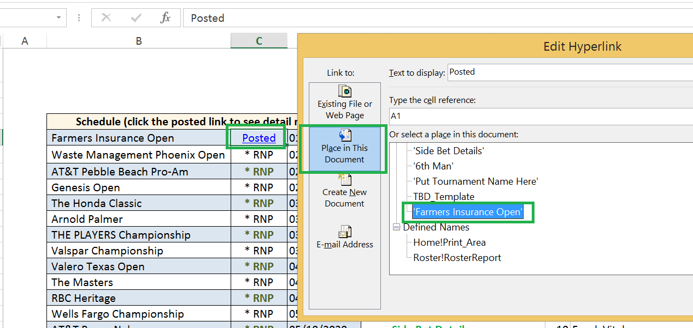

1. Once all changes have been updated to the Index.Html in Excel. Save the document

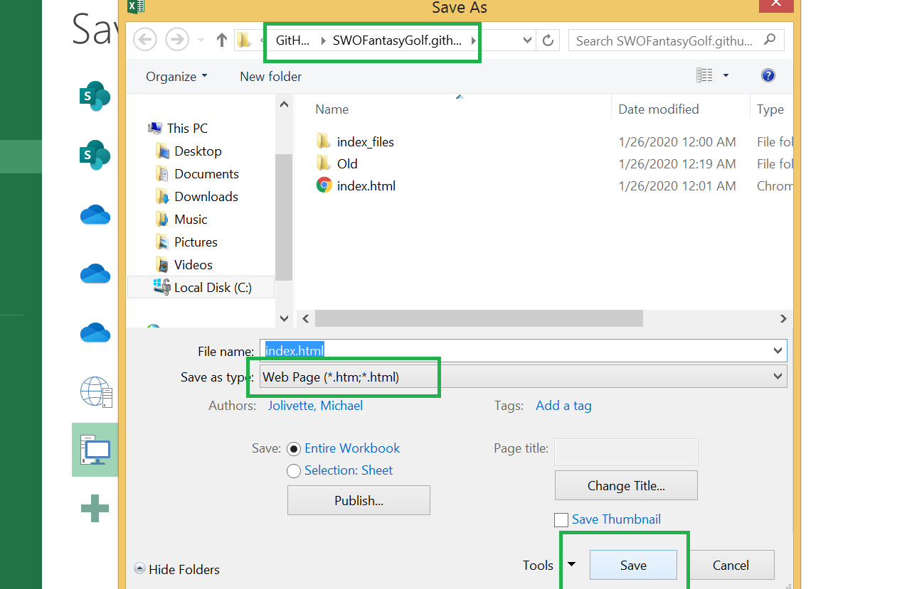

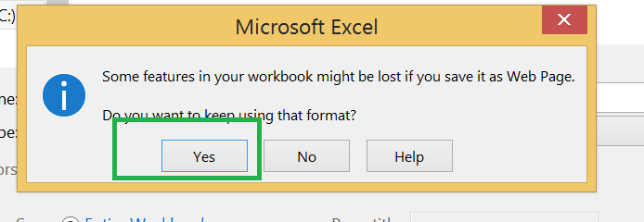

8. Using the GitHub Desktop Client.

1) add a summary description

2) click the commit to master

3) click push to origin

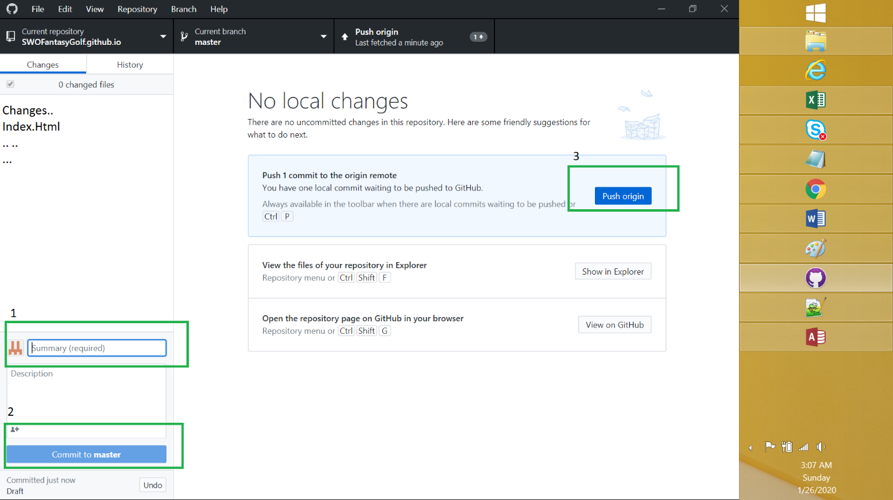

9. Test the Site contains the latest changes.